**COMPANY PROFILE**

**About Micromoney:** Micromoney is an international innovative fast-growing Blockchain based, FinTech company specializing in financial consulting, credit scoring and online peer2peer lending in emerging markets. Micromoney uses its proprietary IT infrastructure and risk management capabilities to develop innovative financial solutions. We proud to bring financial innovations into Emerging Markets

**Name of the Company:** Micromoney Company Limited

**Slogan of the Company:** “Most reliable partner for your urgent financial needs”

**Legal form of business:** Company Registration Number: 778(FC)/2016-2017(YGN), Incorporated in the Republic of the Union of Myanmar

**Registered Office address:** Room.1406(A), 14th Floor, Sakura Tower, 339 Bogyoke Aung San Road, Kyauktadar Township, Yangon, Myanamar

**Company Vision:** To be ASEAN first and largest online market place connecting 1 billion of borrowers and investors by establishing peer-to-peer financial platform with the aim of providing diversified financial services: credit bureau + credit scoring, lending, insurance, etc. To increase business WORLDWIDE!

**Company Mission:** To establish the first and pioneer P2P lending platform in order to provide premium financial services in ASEAN region: Myanmar, Indonesia, Philippines, Shri-Lanka, Vietnam, Malaysia, Singapore, China + Hong Kong. To increase business WORLDWIDE!

To be an innovative market place where both borrowers and investors can meet through online platform

To provide solutions for emergency financial needs with affordable rate

To mitigate the risks by diversifying investors’ investments among different borrowers

To earn attractive returns for investors

**Value:** Integrity, leading innovations and excellent premium services

**Purpose of the business:**  Consultancy Services for Emergency Financial Needs

**Authorized capital**: USD 1 million

**Contact number:** +95 9 9797 41747

**Email:**  CEO@money.com.mm

**Website:** <http://money.com.mm/>

**About Micromoney:** Micro-money is a company focused on micro-financing in the money lending industry and we aim to provide the best professional solution to your financial needs in Myanmar.

We provide premium financial services to your everyday needs without any collateral requirements. Easy approval procedures with the shortest processing time will make the loan application simple and fast.

Micro-money offers an innovative approach to consumer Online Cash Advance products, which allows us to adapt to your varying needs.

Rapid

This is Micromoney’s motto. We made sure that all it takes is a few minutes for you to complete a hassle free online application. Upon approval, we make sure that you are able get your money in your bank account within 24 hours.

Simple

Skip time-consuming queues, complicated application procedures and long approval waiting time. The simple application process, by filling out our online application form to sending a valid proof of your identity, place of residence and income, everything is completed with just a few clicks from your mobile device or computer.

Transparent

We make it a priority in being transparent with your loan details. Building trust by making sure that you are clearly informed of your online cash advance terms and conditions.

**Numbers of BoDs:** 3 Directors

**Directors’ profiles:**

1) **Mr.** **Anton Dziatkovskii** - successful entrepreneur, diplomatic negotiator, extreme seller and creative expert in marketing. Passionate and hardworking business leader with more than 13 years of experience in different positions within FinTech, Retail and E-Commerce.

Working for the Infinto since 2016, I have been given great opportunities to participate in the international development of our company in Asia.

My responsibilities is to open new markets from scratch :)

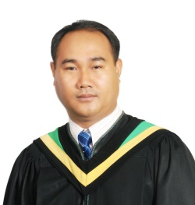2) **Mr. Sai Hnin Aung** who has more than +15 years’ experience in microfinance/financial industry led by INGO and Commercialized Foreign MFIs and managed team of up to +550 staffs and +/- USD 40 million loan portfolio with the best portfolio at risk rate. He was able to scale up the process including software technology by introducing new technologies with T24 MCB core banking system, UT Mobile, UT Net and Bio-metric devices as a pioneer of Microfinance industry in Myanmar.

He earned Bachelor Degree in Myanmar and received Master of Business Administration from Monywa Institute of Economics, Myanmar. Furthermore, he also built up his capacity by granting Master in Regional and Rural Development Planning from Asia Institute of Technology, Bangkok, Thailand. He has a lot of networks with Microfinance Institutions in Myanmar and also have better relationships with Myanmar Microfinance Association and regulators from Ministry of Finance and Planning.

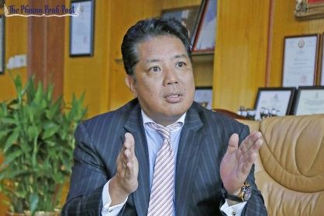3) **Mr.** **Nagata Tetsuji**, dynamic, energetic, self-motivated, self-driven, quick learning and well-organized individual dedicated with a positive attitude. His background – Investment Banking, Private Equity, Corporate Advisory and Real Estate Investment. Currently he successfully manages big venture fund EastWing capital, lead Real Estate constructing project, manage microfinance company, build car parking and support a lot of project on emerging markets of Cambodia, Vietnam, Malaysia and Myanmar. He has strong interpersonal, coordination and negotiation skills that is fully committed to excel.

**Staff Employed:** 56 staffs

**Organization Structure:** Attached

**Corporate Governance:** The Board of Directors has approved the charters of the Audit Committee, Nominating and Remuneration Committee, Credit Risk Committee, which outline the respective functions and responsibilities of those committees, as well as Micromoney’s Corporate Governance Guidelines.

**Partners: in Myanmar: OK Dollar, Mykyat, TrueMoney, AYA bank, CB bank, KBZ bank, AGD bank**

**Financial information:** Total assets reach to USD 1,000,000